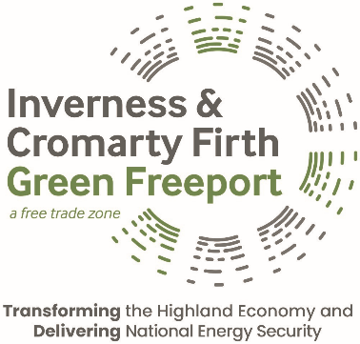

GREEN FREEPORT CAPACITY FUND

APPLICATION FORM

APPLICATION YEAR 2025-26

Please complete all questions below and submit your response by 1ST August 2025.

Responses should be emailed to info@greenfreeport.scot or by post to:
Inverness & Cromarty Firth Green Freeport
UHI House
Old Perth Road,
Inverness
IV2 3JH

- What is the full name of your charity / organisation?
Click or tap here to enter text.
- What is your charity number? (if applicable)
Click or tap here to enter text.
- Main contact name:
Click or tap here to enter text.
- Email address:
Click or tap here to enter text.
- Phone number:
Click or tap here to enter text.
- Please provide an overview of your charity / organisation, including its purpose and main activities.
Click or tap here to enter text.
- The amount of funding available per application is £2,000. Funds must be drawn down within 6 months of allocation. Please confirm acceptance of these terms.
Click or tap here to enter text.
- Please outline the project start date, duration and expected completion date which the requested funding will contribute towards.
Click or tap here to enter text.
- Please include any contributions from other funders or sources of match funding for the project. Applications which can demonstrate additional funding streams will score more highly than those which do not. If the requested funding from the Green Freeport Capacity Fund will contribute towards 100% of the project, please advise.
Click or tap here to enter text.
- Please provide a clear outline of how the Green Freeport Capacity Fund will complement the overall funding strategy for the project.
Click or tap here to enter text.

Funding applications will be assessed against a scoring matrix and funds will only be allocated to groups which meet ALL three of the funding criteria as detailed below. If the funding application cannot address all three criteria, funding applications will not be considered.

- Locality of project: the group / organisation which will benefit from the funding must be based in whole or in part in the Green Freeport area (see map below). Please provide details to support this criterion.
Click or tap here to enter text.
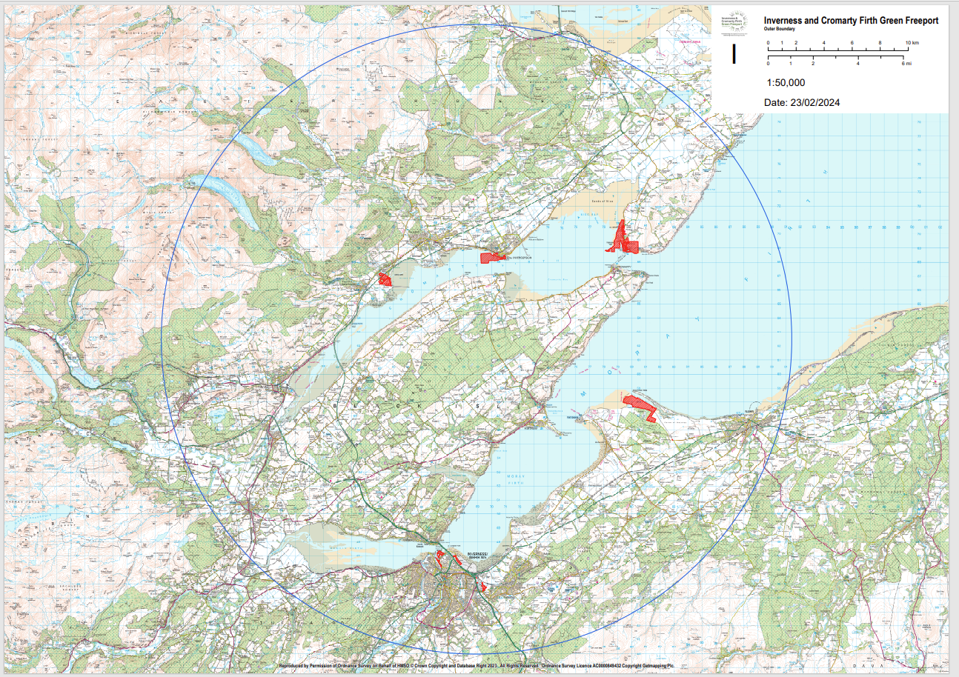
- The funding must be used to support opportunities for those who historically have faced barriers to work or accessing skills, e.g. young women, persons with a disability, economically disadvantaged. Please provide details on who this funding would benefit and how you intend it to be used. Please include any relevant outputs or deliverables.
Click or tap here to enter text.

- Funding applications must demonstrate that an element of the initiative will contribute towards the transition to green energy and / or biodiversity enhancement or environmental improvement. Please provide details of how your charity / organisation is helping towards any of the above areas for the Highlands.
Click or tap here to enter text.
- If successful, please provide details on how you intend to promote the activities linked to your funding application, e.g. press article, social media post, etc.
Click or tap here to enter text.

Thank you for your application. All applicants will be notified of the outcome of their application.

